**1. 什么是Scientific Model (Properties和Purpose)?**

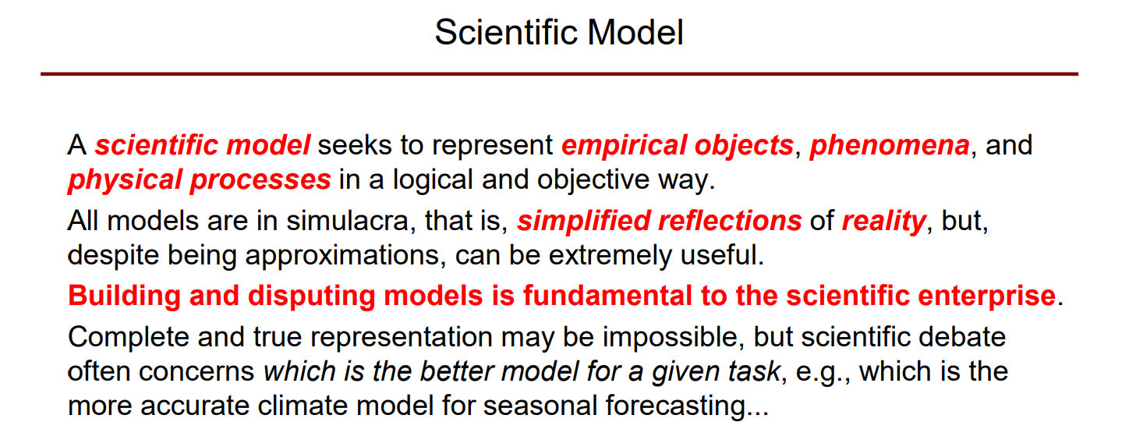

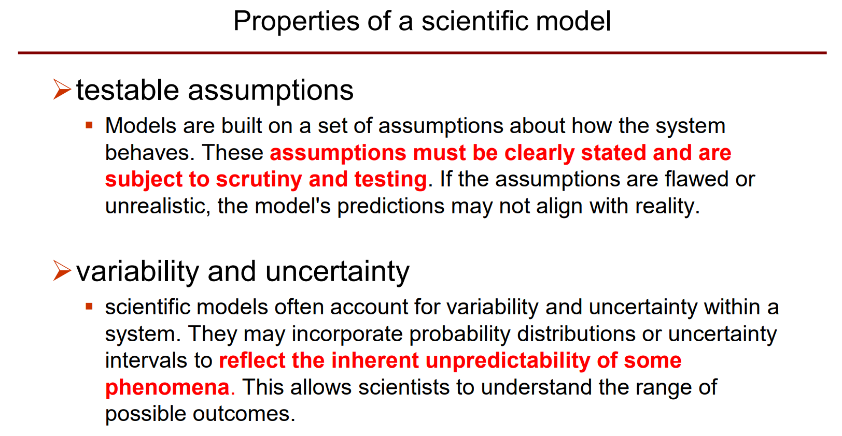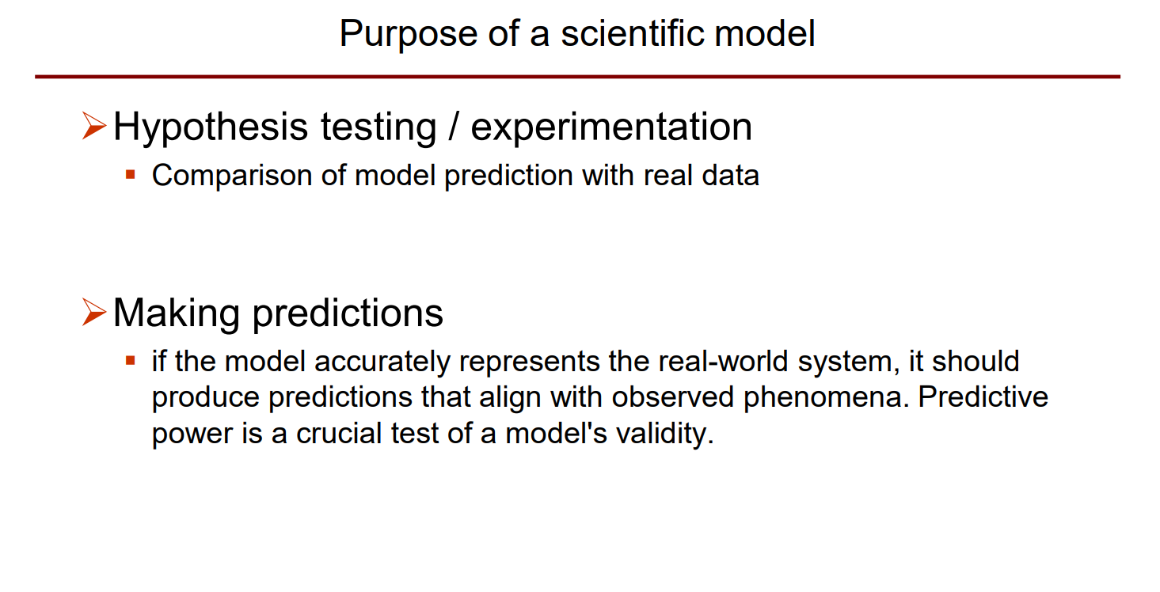

**2. 什么是Modeling?**

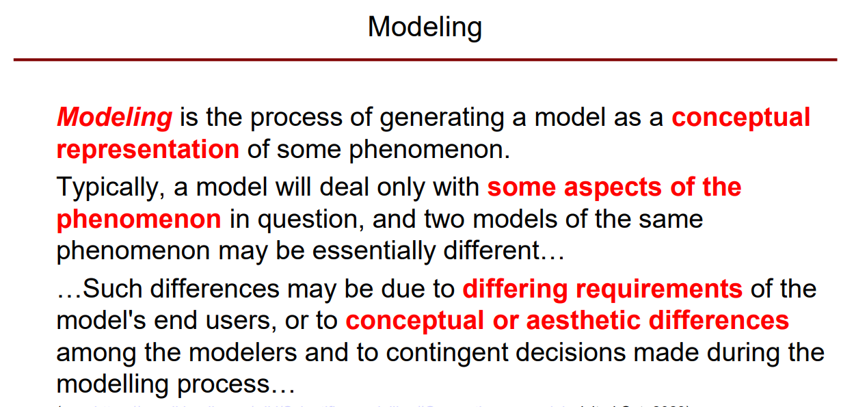

**2.1 (Modeling包含哪些过程) ?**

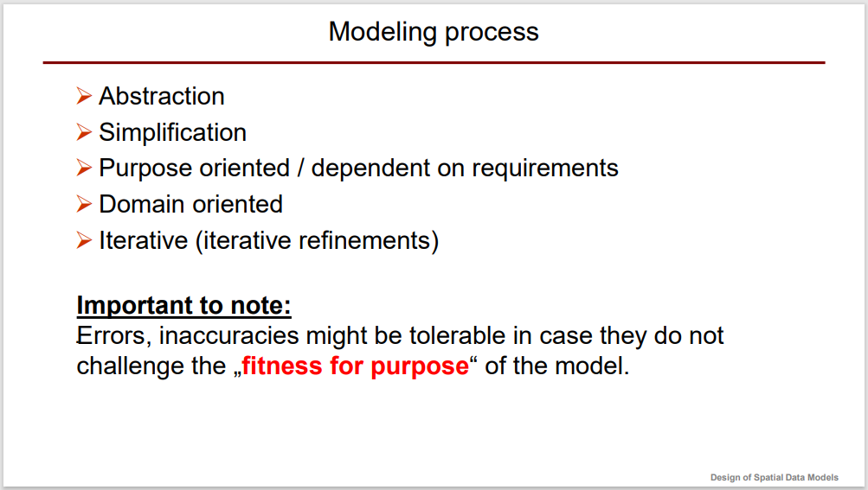

**3. 什么是Data model?**

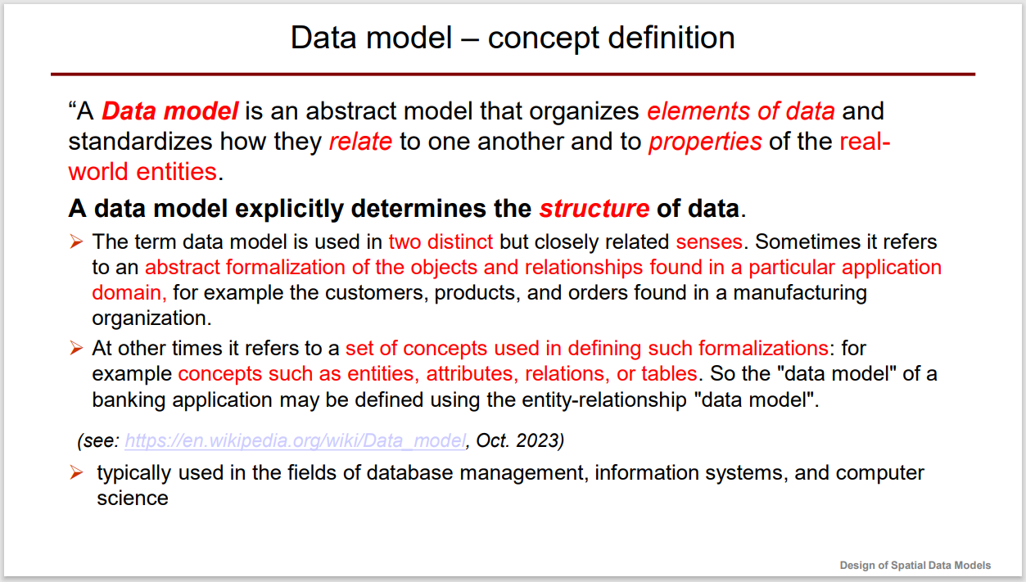

**4. 为什么我们需要Data model?**

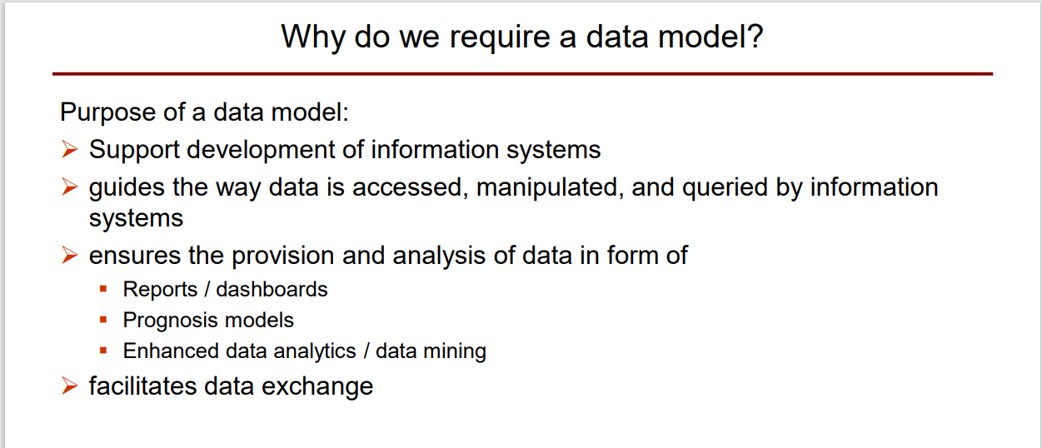

**5. 什么是Spatial Data model (包含哪些数据类型)?**

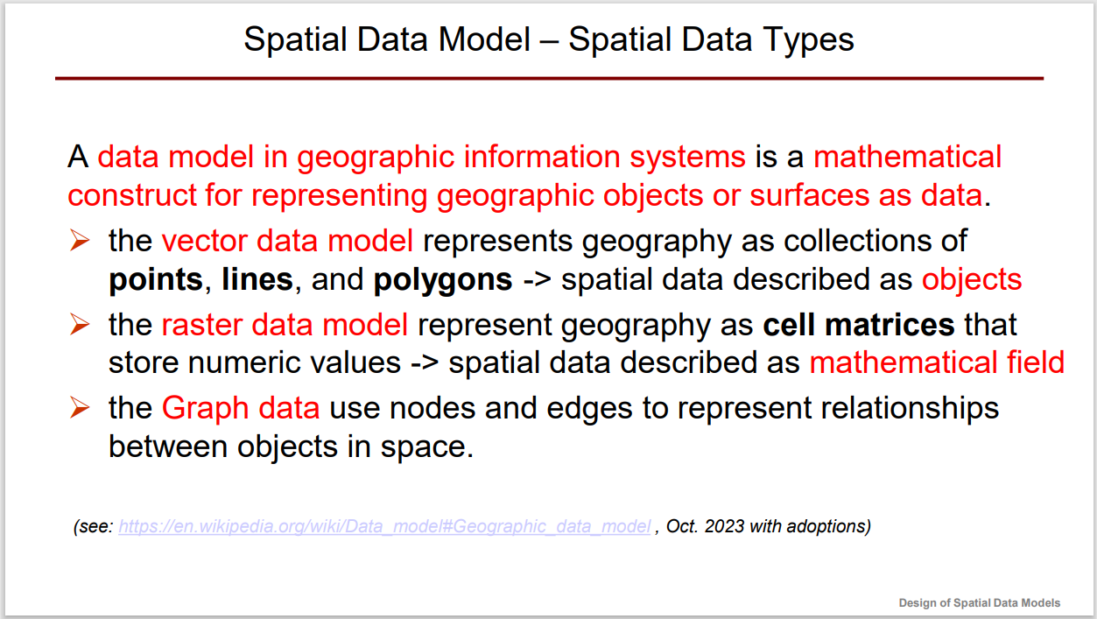

**State Park forest cover:**

**Object based:** forest cover described as vector model in terms of polygons (using a specific semantic);

**Flow based:** forest cover described as raster model in terms a function

**6. 对Spatial Data model的Requirement有？**

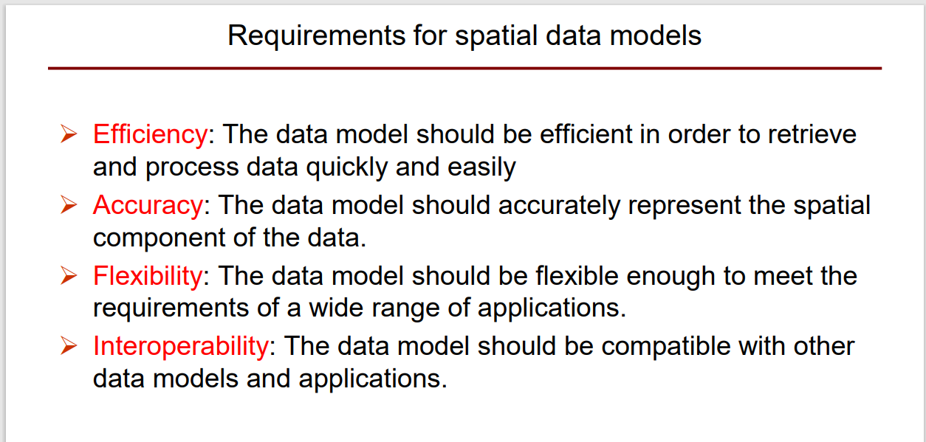

**7. Vector和Raster的各自应用？它们各自的优缺点？**

答：第一问自己想。

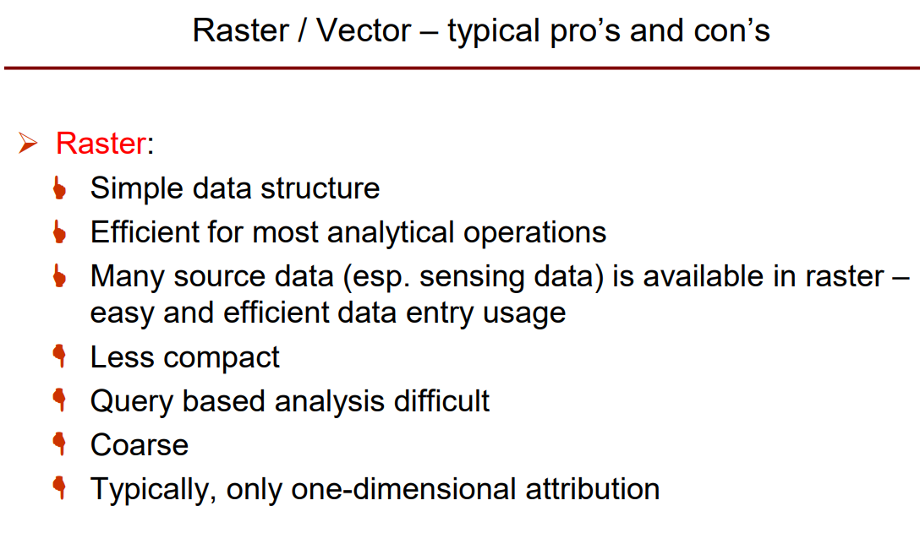 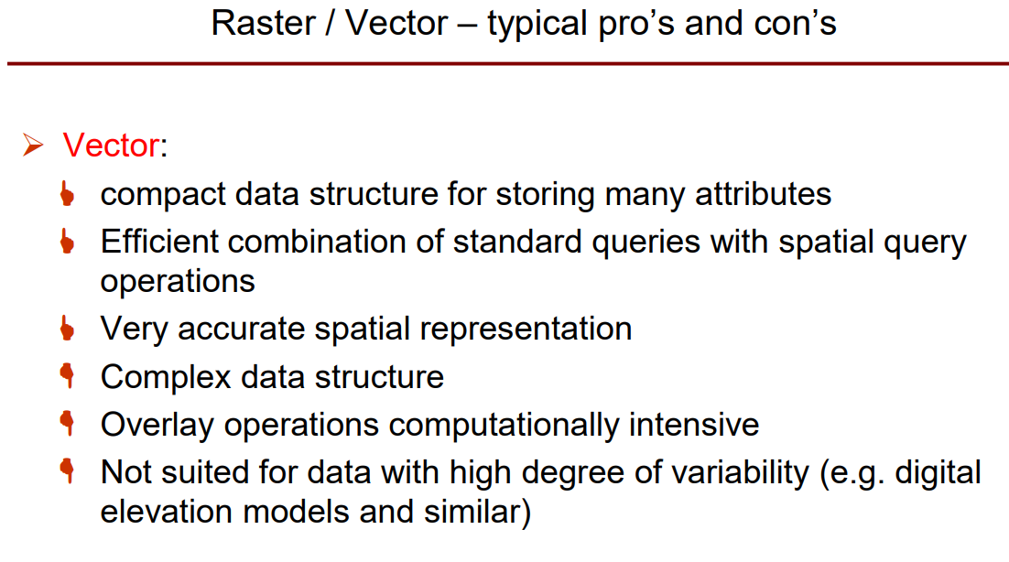

**8. 什么是Data modeling?**

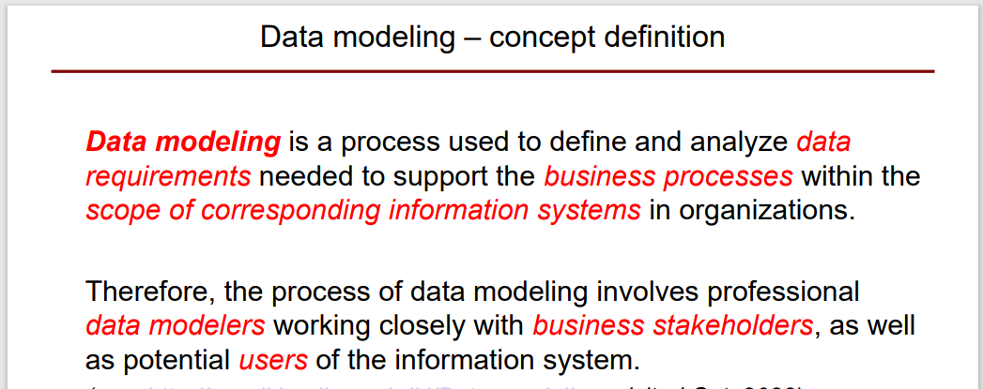

**9. 什么是Business process & stakeholder?**

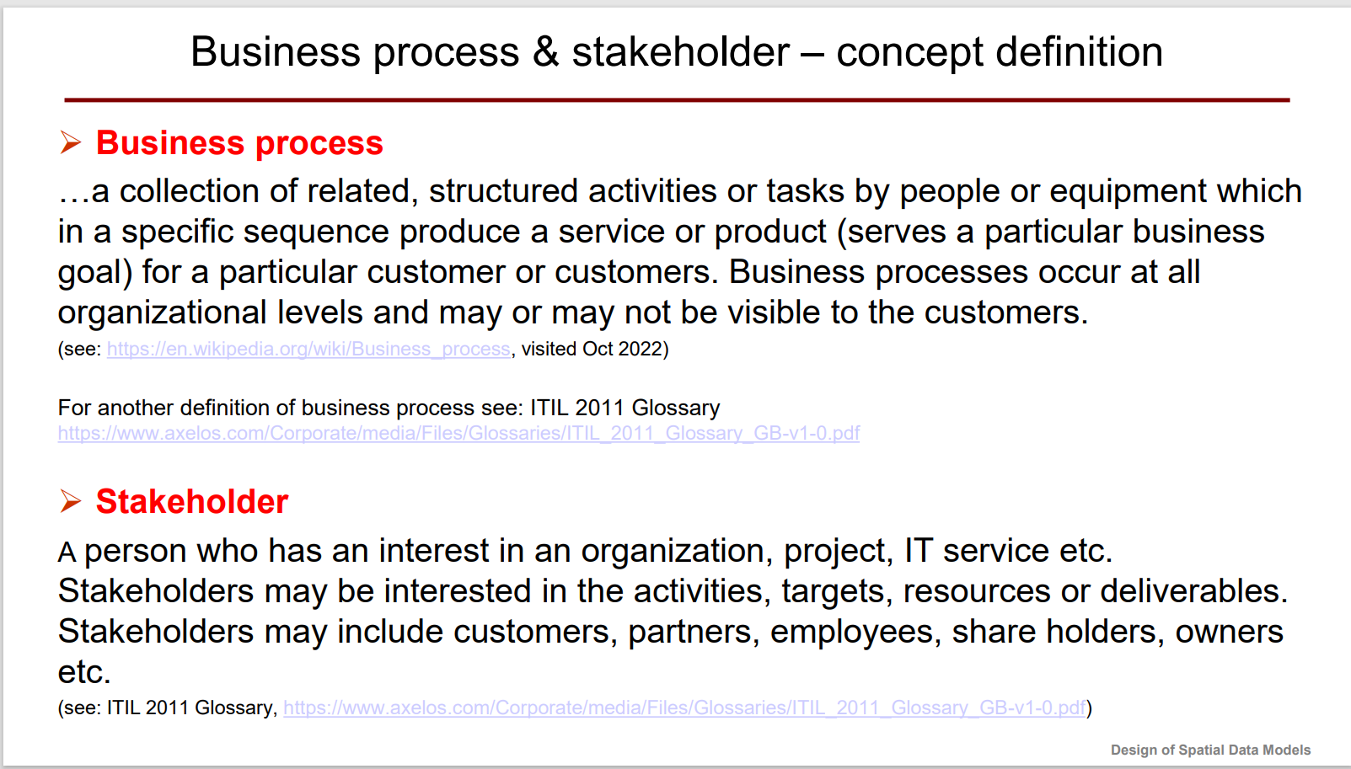

**10. 什么是Entity和Entity Type?**

**Attributes有哪些种类？Mandatory/Optional/Conditional.**

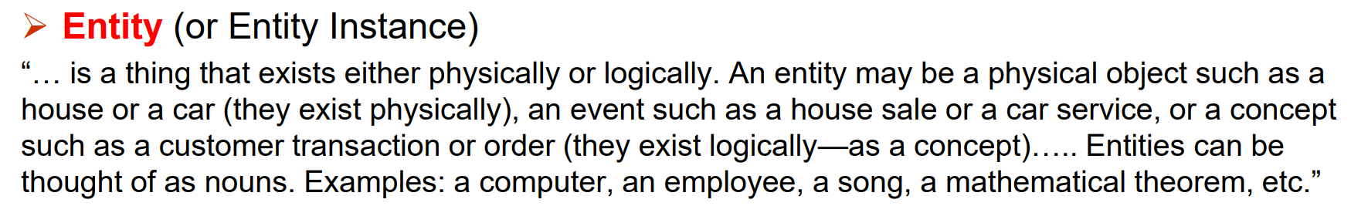

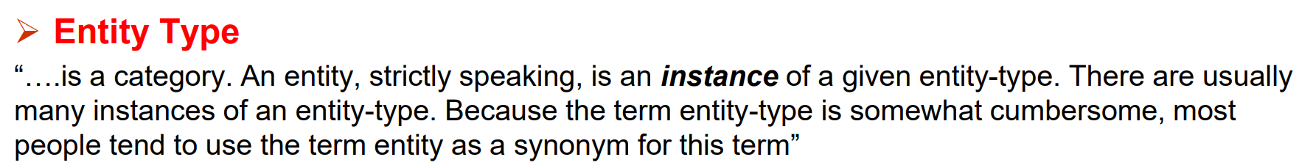

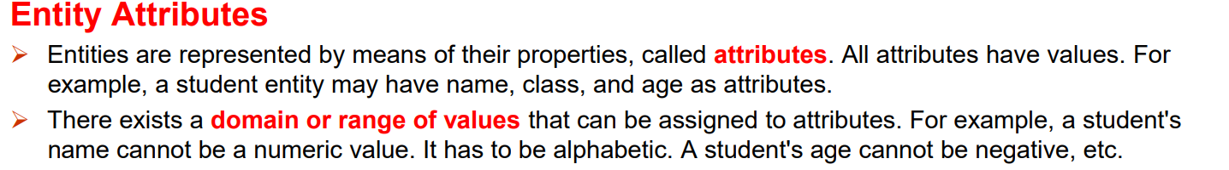

**11. 什么是Relationship 和 Role?（见ppt3）**

**12. 什么是CDM？**

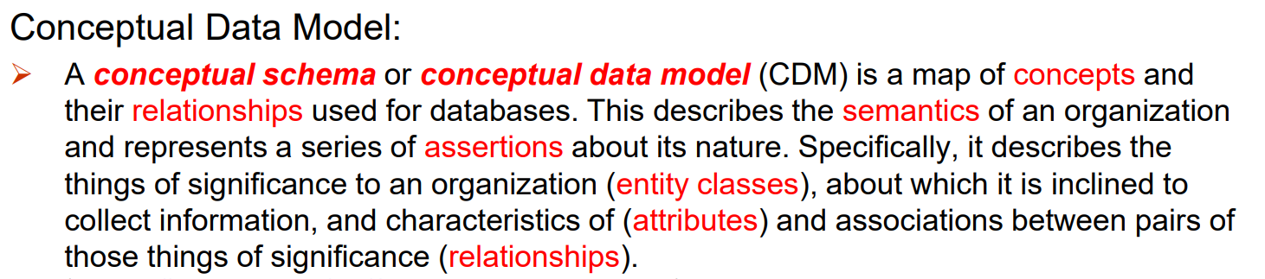

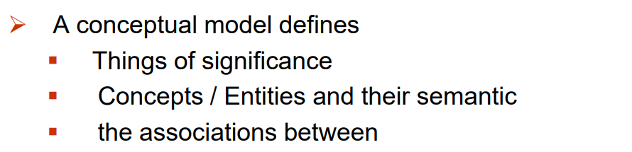

**🤔 Take at least one entity! Describe clearly the entity!**

**Hints: a …… that defines…, usually identified by …….**

**13. 什么是data dictionaries？**

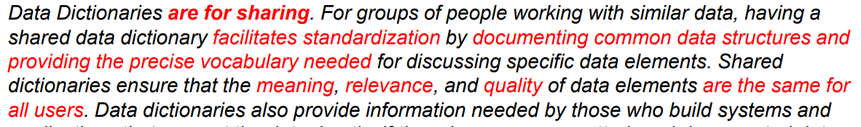

**14. The Rule of sharing data？**

**Hints: Master data、“Mapping rules” and Rules setting(Extract Transform Load (ETL)-FME).**

**15. 什么是LDM？**

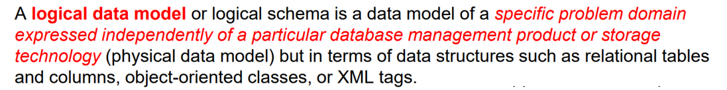



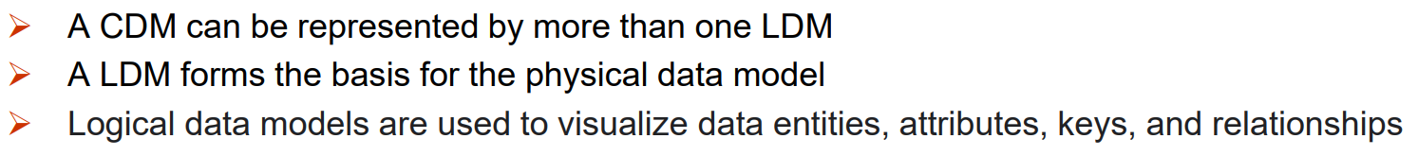

**16. 什么是PDM？**



**17. 创建Data Model需要哪些步骤？**

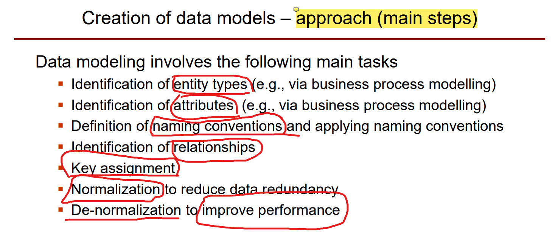

**17-1) Types of relationships?**

|  |  |
| --- | --- |
|  |  |

1) One to One(1:1)

2) 1:N

3) N:M (Require a “link table” to describe)

4) Recursive Relationships: (relationship of instances within an entity)

**Hint:** If a N:M relation appears in Recursive Relationship, then we also need a ***Link table,*** like *“Assemble”* for *product*.

|  |  |
| --- | --- |
| **a one to many(1:N) Recursive Relationship:** | **a link-table of many to many(N:M):** |

**17-2) Assignment of Keys?**

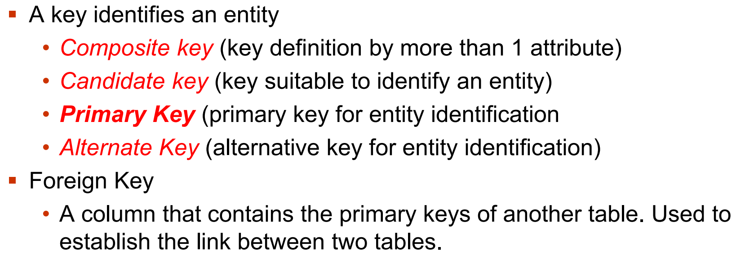

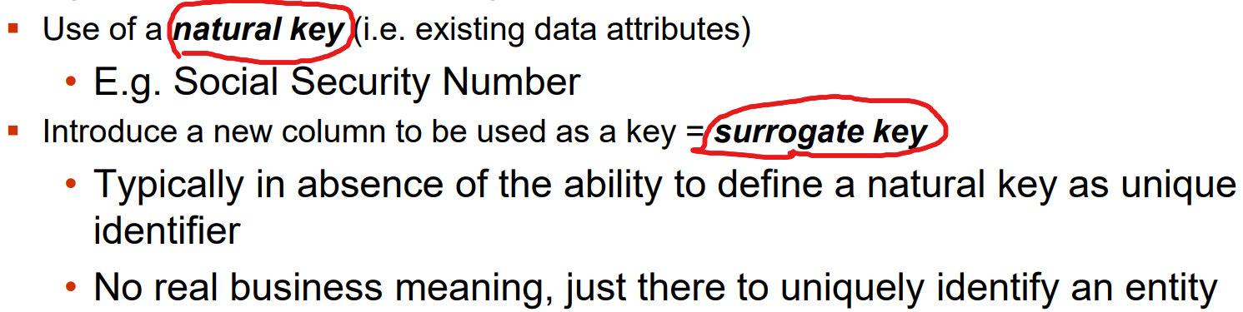

**Terminology: Model, modeling, data model, data modeling, business process, ….**

**➢ What is a CDM, LDM and a PDM and how do they differ from each**

**other?** difference lies in 1) level; 2) technical level; 3) focusing on…

**➢ What are keys, what kind of keys can you name and what are their**

**meaning?** 17-2)

**➢ What types of relationships do you know?** 17-1)

**➢ Can you explain normalization. Explain1NF, 2NF and 3NF?**

**Data normalization** is a process in which **data attributes** within a **data model** are organized to **increase the cohesion of entity types**. So, the goal is to **reduce data redundancy** and **addresses** potential **abnormalities**.

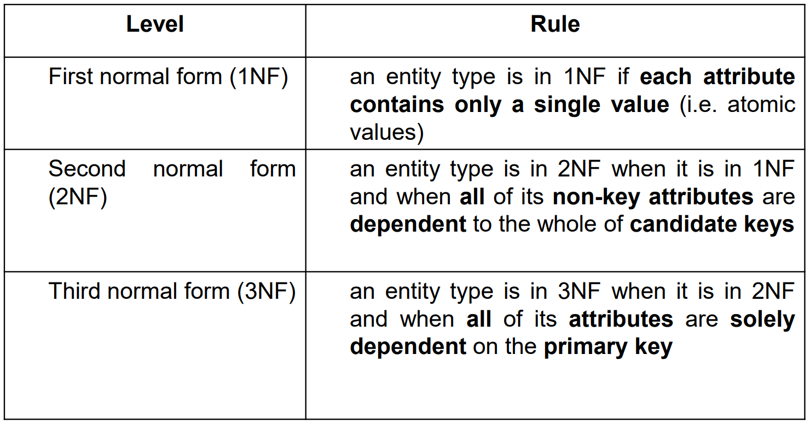

**➢ What is the star schema? What is the setup of a star schema?**

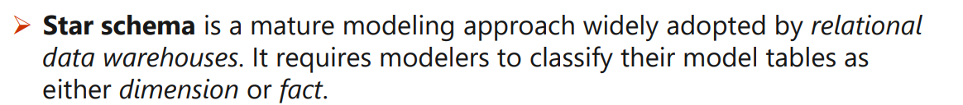

**Setup1:** Dimension tables describe business entities—the things you model. Have a key column as identifier.

Which determine the ***dimensionality*** and ***granularity*** of a Fact table.

**Setup2:** Fact tables store events. A fact table contains dimension key columns that relate to dimension tables.

**➢ Can you explain the steps required to create a data model?** 17)

**18. Can u name Standard organizations?**

OGC, ISO TC211, INSPIRE, OMG, W3C.[具体内容？]

**OGC**, a **worldwide community** committed to **improving access to geospatial, or location information**.

**ISO TC211**, this work aims to establish a **structured set of standards** for objects information with **a location to earth**.

**INSPIRE**, aims to create a **EU spatial data** inf for the EU environmental policies.

**UML Full-Theme**

**1. What is UML? (略) 2. What UML consists of? (略)**

**3. What is UML Capabilities?**

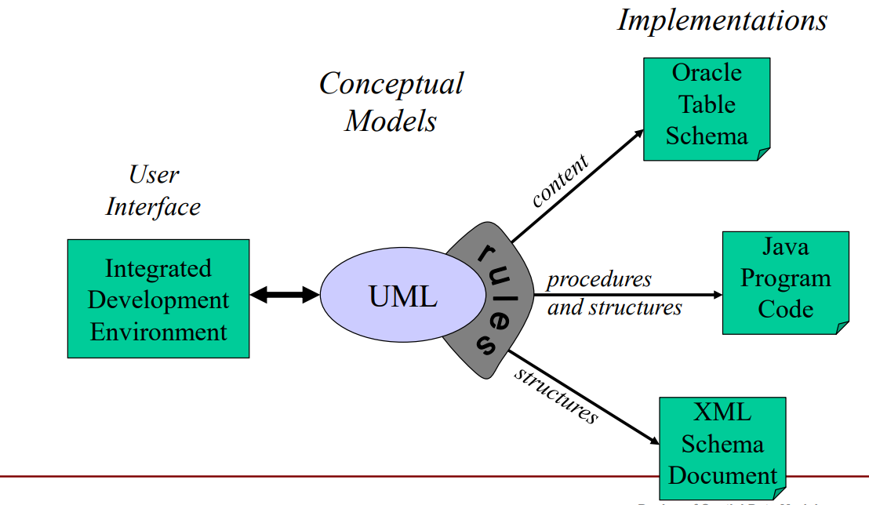

**4. Class? (一定要包含2个部分：传统定义+模型内定义)（略）**

**5. Attributes?**



➢ **The attribute section of a class lists each of the class's attributes on a separate line.**

**➢ Class multiplicity 0..1 means that this attribute is optional. If no multiplicity is given, it assumed to be 1.**

**➢ All attributes must be typed, in a set of legal base types, the constructed/defined types. No default type.**

**6. What is UML Namespace?**

A **namespace** in UML is a container for named element. These **namespaces** are grouped by the means of “**packages**” that contains **elements**.

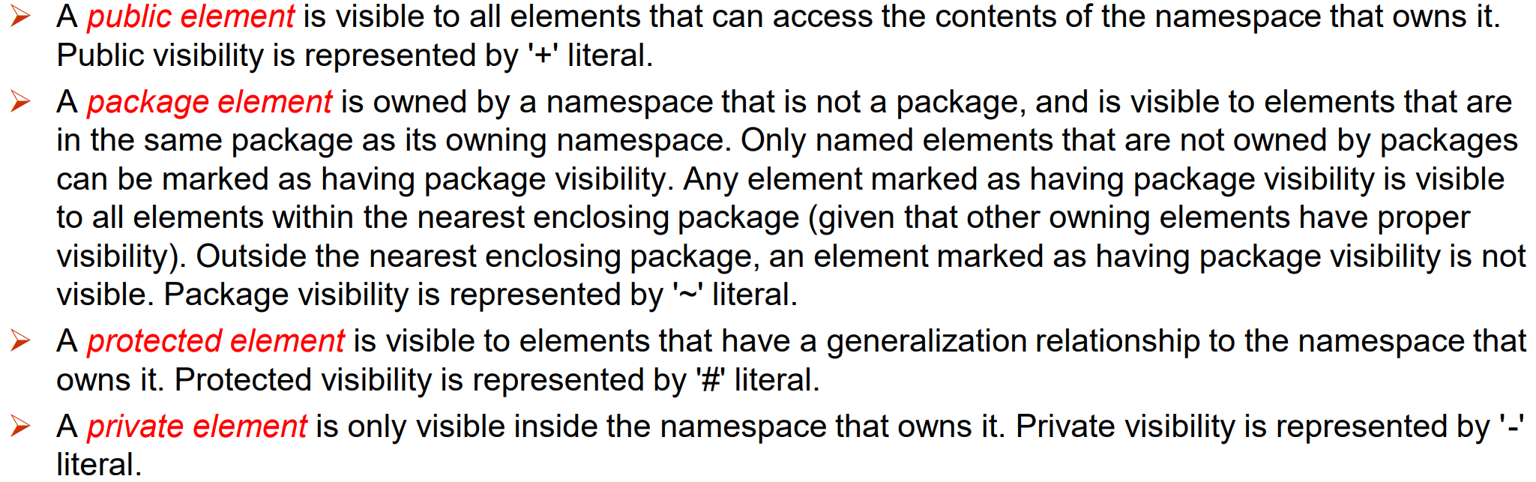

**7. Operations?**



The **operations** are documented in the **bottom compartment** of the class diagram's rectangle, which also is **optional**.

**8. How to describe an Association?**

**1) What is an association?**

**2) Type of Association. like** *who knows who.*

|  |  |  |  |
| --- | --- | --- | --- |
| Bi - directional | Uni - directional | Recursive association | Inheritance |
| Base-Aggregation | Composite-Aggregation | 🧨association class table |  |

**3) Describe operation**

正说：…is a … to report on the business class “BankAccount”

反说：“BankAccount” can play the role of …

**4) Describe association Multiplicity**

**5) For example.**

**9. Use of Spatial Standards in UML?**

It defines **principles and framework** of the use of UML for **spatial data** modelling.

**10. What is Feature?**

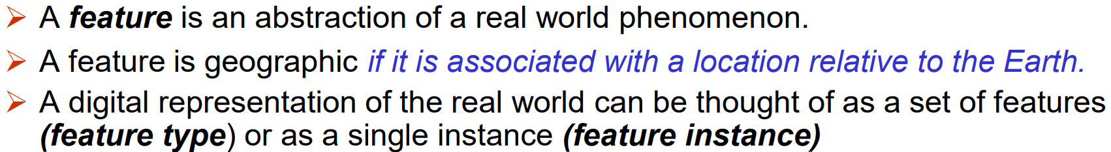

**11. What is Schema\Type\Instance?**

* **Schema:** it is the **formal description** of a model.
* **Type:** **groups** feature **instances** **into classes** with common characteristics.
* **Instance:** represented as **discrete phenomenon** associated with its geographic and temporal coordinates.

**12. 🎆Stereotypes in Spatial data context? 🎆**

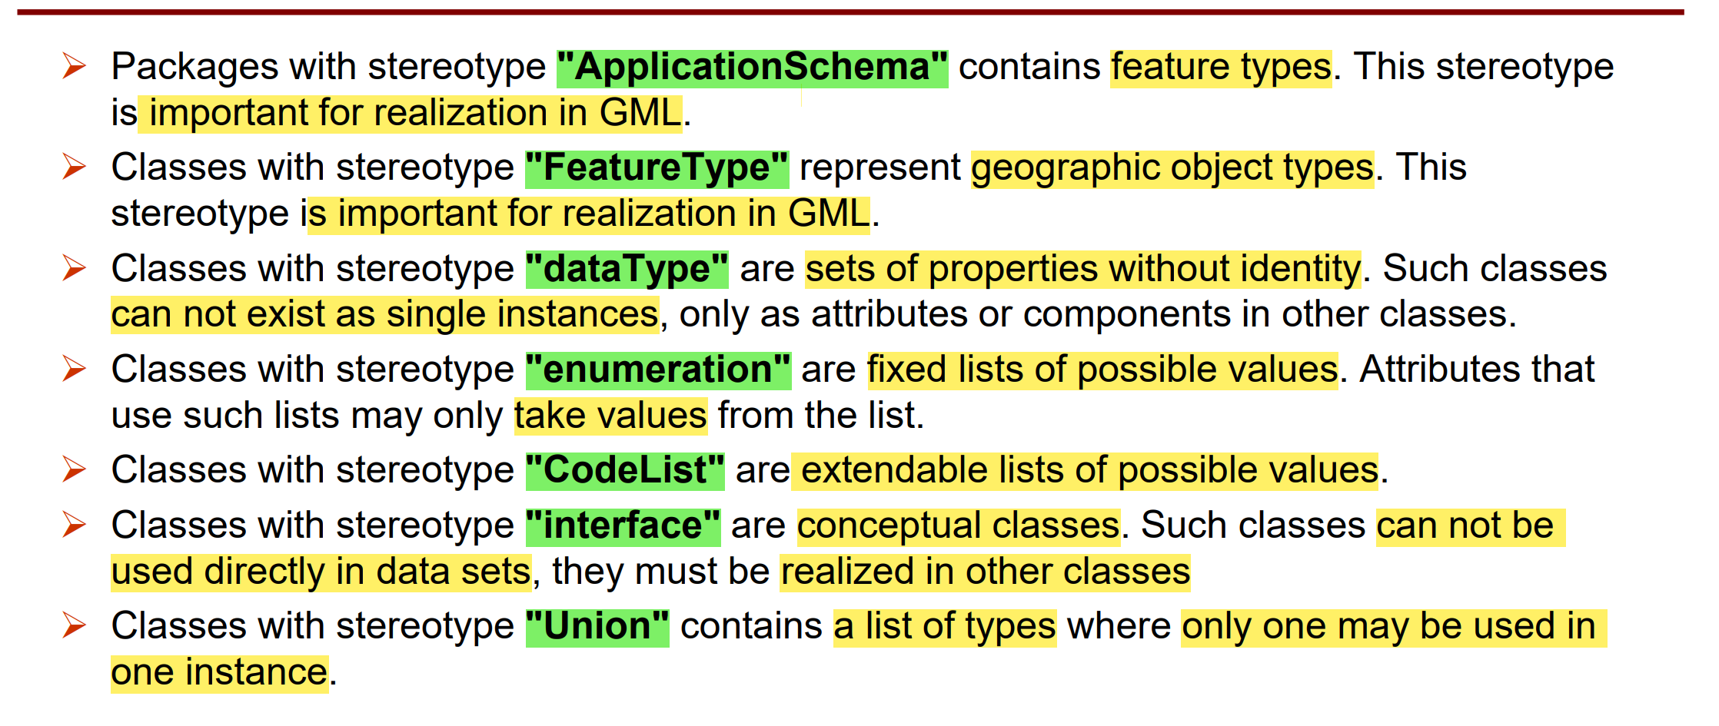

**UML class diagram**

**An Example designing property cadaster in GIS?**

**Step 1: Identify Main Entities (Classes).**

**Parcels:** Represent land parcels. Attributes may include parcel ID, size, location, etc.

**Buildings:** Represent structures on parcels. Attributes may include building ID, size, type, etc.

**Property Owners:** individuals owning parcels or buildings. include owner ID, name, contact details, etc.

**Taxes:** taxes associated with parcels or buildings. Attributes may include tax ID, amount, due date, etc.

**Parcel Usage:** Represent the usage or purpose of each parcel. Attributes may include usage type, restrictions, etc.

**Step 2: Define Attributes for Each Class**

**Step 3: Identify Relationships Between Classes**

**Step 4: Consider Multiplicity and Role Names**

**Step 5: Add: Constraints or business rules**

**Step 6: Geometry types-GM_Location\GM_Geometry\GM_SR**

**Vice versa, how to describe a diagram?**

**1_Entities; 2_Relationship:** there is an bi-directional relationship between <x> and <y>, indicating that…**;**

**3_Multiplicity:** the <x> can hold number of <y>, but the <y> can hold number of <x>.

**🎏XML Basics**

**1. What is XML?**

1. XML tags are not predefined. You must define your own tags.
2. XML with a DTD or XML schema is designed to be self-descriptive.
3. XML is a W3C recommendation.

**2. What is a well formed XML doc?**

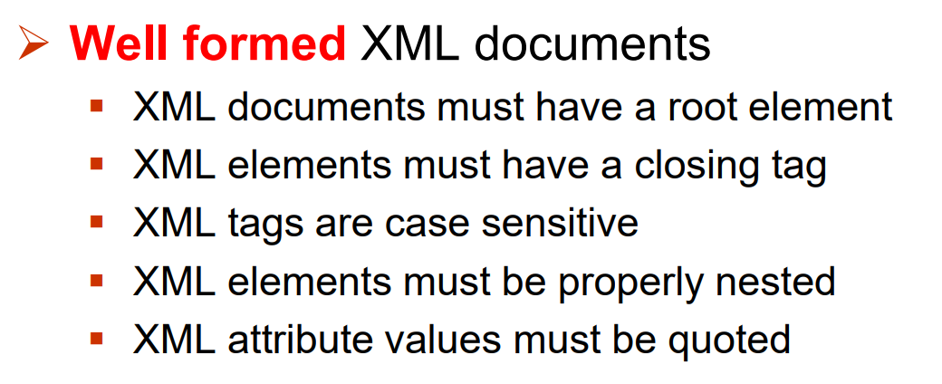

**3. What is the advantage of XML?**

* XML is platform independent and programming language independent.
* XML supports unicode.
* The XML data can be changed at any point of time without affecting the data presentation.
* XML allows validation using DTD and Schema.
* XML simplifies data sharing between various systems.
* XML based product for specific information domains

**3. What is the XML Schemas?**

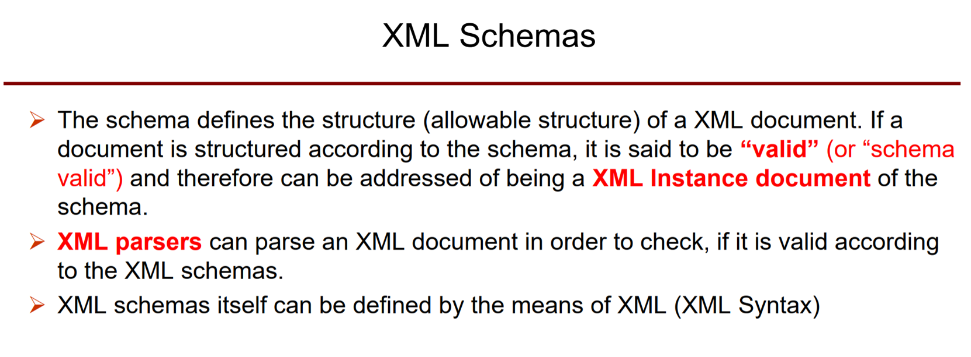

**3. What is XML Namespace?**

|  |  |
| --- | --- |
| **1) Declaration in the root element.** | **2) Use before a vocabulary.** |

**3) Definition**

**XML Namespaces** provide a method to **avoid** **naming conflicts** of elements.

Because in XML, element names are **defined** by the developer. This often results in a **conflict** when trying to **mix XML documents** from different XML applications.

**4) Facilitate** ->

**In the example above:**

1. The xmlns attribute in the first <table> element gives the h: prefix a qualified namespace.

2. When a namespace is defined for element, all child with the same prefix are associated with the same namespace.

3. Namespaces can also be declared in the XML root element。

**5）Declaration example**

**XML Schema** itself provides a set of **standard elements and types** for

**defining the structure** of a document and the **types** of data.

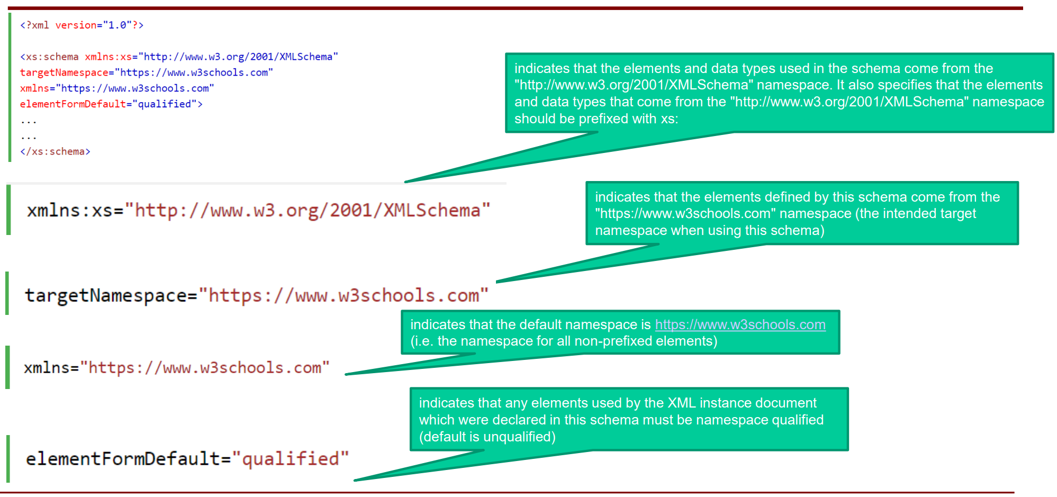

**- GML -**

**1. What is GML?**

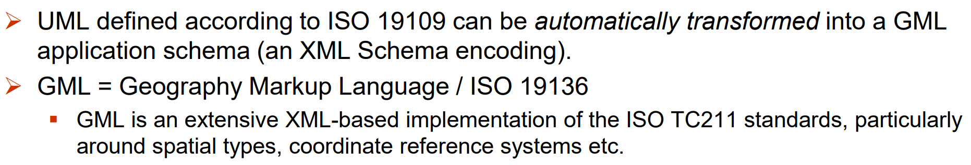

**2. GML schema?**

1. **UML Application Schema**（Use a **schema language** to model **GI** in UML Application Schema）；

2. **GML schemas**（standard elements and types）；

3. **GML Documents**（get real-world objects as data）

**3. Problems Complexity of GML causes? & How to solve?**

Complexity can cause a problem for the data exchange:

**1) Dynamic feature** support **2) Inclusion of time** dimension **3) Complex geometries**

**So,** GML Profiles help to **limit complexity** of GML. **OGC** defines profiles for GML, but **most support SFP0**.

**4. Example of GML Application Schema?**

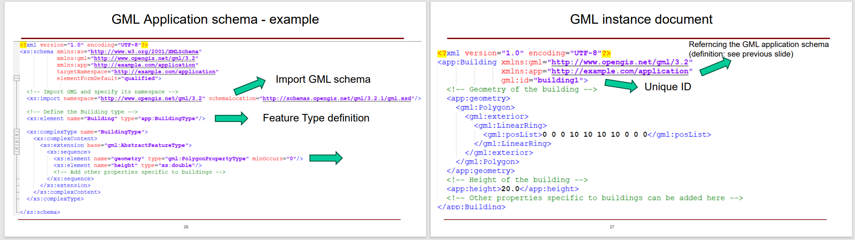

**4. How does the Geospatial Web work?**

1) Enabling the geospatial web；

2) use GML as the common language of the geospatial web；

3) Mapping GML Data.

**- GFM: a kind of GML Application schema**

**1. What is a GFM?**

GFM is a **meta-model for developing conceptual models of feature types and their properties**.

As there is no GFM-language and the **conceptual schema must be expressed in a CSL**.

**2. Purpose of GFM?**

The GFM is a model of the concepts required to classify **a view of the real world**.

GFM establish a basis for **the classification of features**, WHILE UML-metamodel provides any kind.

**3. GFM provides the framework for…?**

* conceptual modelling of features;
* definition of application schemas;
* use CSL for application schemas;
* transfer CDM to data types in the appSch;
* integrate standardized schemas with the appSch.

**4. What is AS?**

1. Provides the description of **data structure and content**.

2. Specifies the **data operations**

3. Expressed by **CSL**

**5. 💕Type of Feature relationships to describe?(*4)**

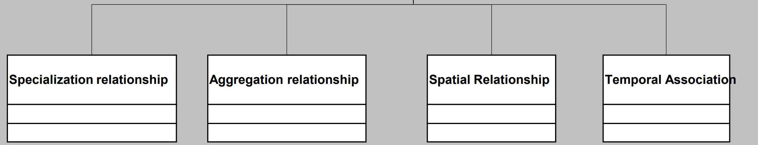

**6. 💕Type of Feature relationships to describe? (*5)**

